Submission by: Pranav Medhi

SQL queries used:

For Global data csv:

Select *

From global_data

For city_data csv:

Select * From city_data where city='Dallas'

* What tools did you use for each step? (Python, SQL, Excel, etc)

Excel

* How did you calculate the moving average?

I calculated the moving average for 10years, using the same method as used in the explanation for moving averages in a spreadsheet. I just selected all the rows below the first one and Ctrl+D and got all the values in one go.

* What were your key considerations when deciding how to visualize the trends?

I thought of the following things while deciding how to visualize the trends:

1)For selecting the moving average of 10years, I considered the situations such as natural disasters such as earthquakes, hurricanes, epidemics, draughts, floods, these disasters and the changes accompanied can be smoothed with a 10year moving average.

2) For capturing the perfect visualization I omitted some years from the global temperature averages to make it the same range as Dallas which was 1820-2013.

3) I did check for missing values or years, And didn’t find any missing values.

Line Chart:

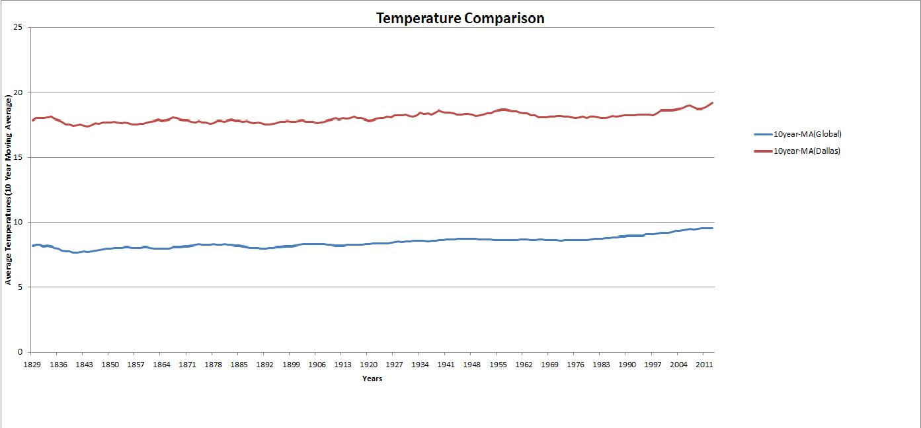

Observations:

1)From the line chart it is clear that Dallas has always been hotter than the global temperature averages. The calculated average temperature of Dallas from 1820-2013 was 18.04 degree Celsius while that of the globe for the same year range was 8.47 degree Celsius.

2)In the range of years 1997-2013 the global temperature average has been climbing slightly with regular increments. While temperature averages in Dallas, also have been rising but with some fluctuations such as the dip in 2008 and again a steep increase moving forward.

3) Generally, the line chart for Dallas has had steep rises and falls as compared to the globe. Where the globe has also had changes but they have been rather smooth.

4) Looking closely at the Dallas line chart, we can say that the peek temperatures witnessed were in the years 1836, 1955, 2004. All in all we can conclude that the worlds, average temperature has been rising steadily. Even though there is just a 2-3 degree Celsius of overall increment over the span of 1820-2013 in the global averages, it is a matter of concern because that 2-3 degrees is just an average and doesn’t specify the extremes, which make the most of the climate change take place.

What is the correlation coefficient?

The correlation coefficient between the 10year Moving averages of global temperature and Dallas temperatures is 0.88 which means a highly positive correlation. Which also means that both of the temperature average move in the same direction, if one increase other has a high chance of increasing and same for decrements.